|  |  |  |  |  |  |
| --- | --- | --- | --- | --- | --- |
| Test Case | Batch Size | Epoch | Learning Rate | Loss | Accuracy |
| 1 | 32 | 50 | 0.001 (Default) | 0.2713 | 0.9180 |
| 2 | 16 | 5 | 0.001 | 1.0518 | 0.6167 |
| 3 | 32 | 10 | 0.001 | 0.8264 | 0.6953 |
| 4 | 32 | 20 | 0.001 | 0.5944 | 0.7969 |
| 5 | 32 | 30 | 0.001 | 0.4746 | 0.8164 |

Test Case 1:

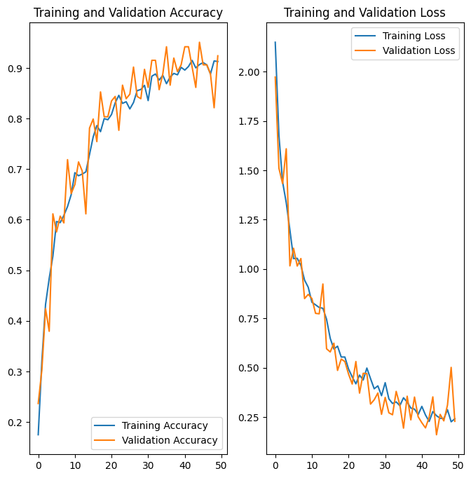

Test Case 2:

